Project Design Phase-II
Technology Stack (Architecture & Stack)

Date | 31 January 2026
Team ID | LTVIP2026TMIDS71750
Project Name | OrderOnTheGo: Your On-Demand Food Ordering Solution
Maximum Marks | 4 Marks

Technical Architecture:
OrderOnTheGo (SB Foods) is built upon a scalable, layered architecture designed to deliver a seamless, reliable, and efficient on-demand food ordering experience. At the foundation, the system consists of user-facing web and mobile interfaces that allow customers to browse restaurants, view menus, place orders, make payments, and track deliveries in real time. These interfaces also support restaurant and admin dashboards for managing food items, orders, and platform activities.
The frontend communicates securely with the backend through RESTful APIs. The backend layer handles core business logic such as user authentication, role-based access control, order processing, payment verification, and notification management. It ensures smooth interaction between customers, restaurants, and administrators while maintaining system consistency.
At the data layer, a centralized database stores structured information related to users, restaurants, food items, carts, orders, payments, and feedback. This data is managed efficiently to support real-time order updates, order history retrieval, and analytics. Integration with external services such as payment gateways and notification services enables secure transactions and timely updates.
The system is deployed on a scalable cloud infrastructure that supports high availability, performance, and growth. Security mechanisms such as encrypted communication, secure authentication, and access control are enforced across all layers to protect user data and transactions. This layered architecture ensures that OrderOnTheGo (SB Foods) remains robust, scalable, and user-centric, enabling a smooth and reliable food ordering experience for customers while efficiently supporting restaurant operations and platform administration.

Guidelines:
• Be customer-first: Design the platform to be simple, intuitive, and accessible for all users, including students and working professionals.
• Ensure convenience: Focus on fast ordering, clear menus, and easy navigation, especially for late-night food availability.
• Protect user data: Ensure secure authentication, encrypted payments, and transparent handling of user information.
• Stay flexible: Build the system using a modular and scalable architecture to support future features and growth.
• Act in real time: Provide instant order confirmations, real-time order tracking, and timely delivery updates.
• Listen and improve: Collect user feedback, ratings, and reviews to continuously enhance the food ordering experience.

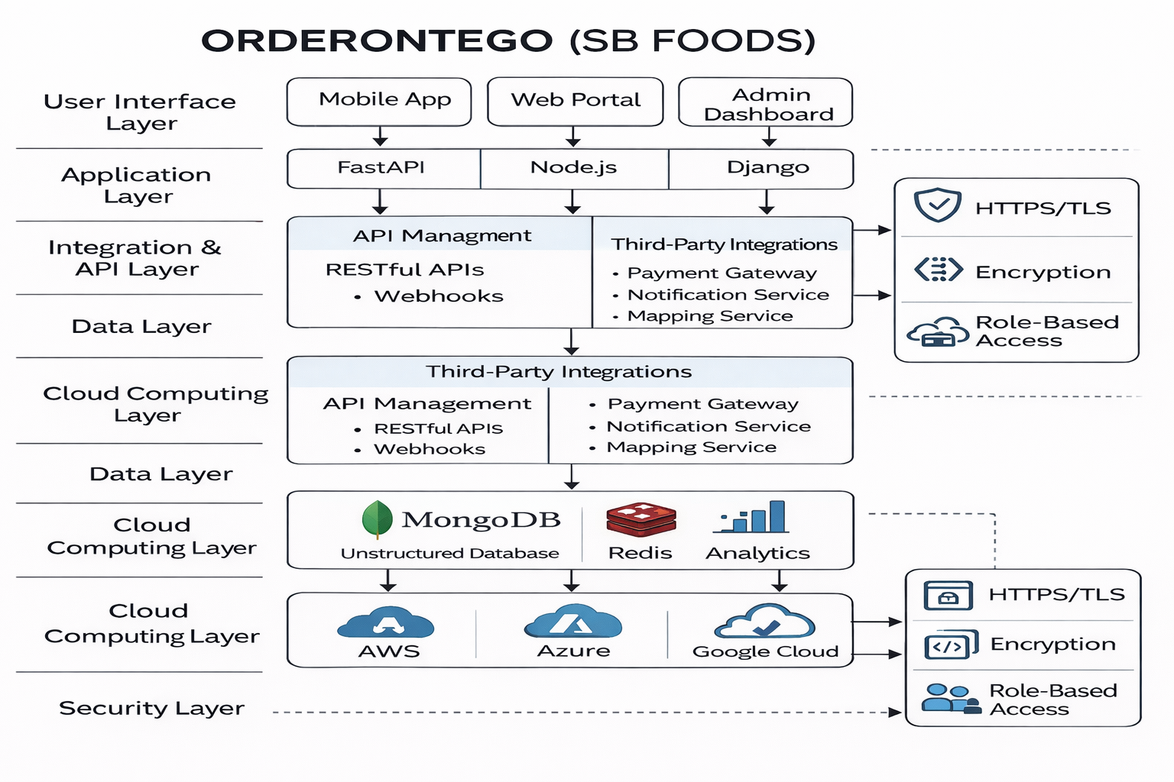

Table-1 : Components & Technologies:
S.No | Component | Description | Technology
 | User Interface |  | React JS
  Web and mobile applications that allow customers, restaurants, and administrators to interact with the food ordering system, browse menus, place orders, and track delivery status.
  Client Devices
  Devices used by customers and restaurants to access the application, including smartphones, tablets, and desktop systems.
  Android, iOS, Web Browsers
 |  |  | Node.js
  Application Logic
  Handles core application workflows such as user authentication, cart management, order processing, payment handling, and notifications.
 |  | Responsible for managing APIs, authentication, authorization, order lifecycle management, and communication between frontend and database. | Node.js, Express.js / FastAPI
  Backend Services
 |  | Enables communication between frontend, backend, and third-party services such as payment gateways and notification systems. | RESTful APIs, Webhooks
  APIs & Integration Layer
 | Cloud Database
  Stores structured application data including users, restaurants, food items, carts, orders, payments, and feedback.
  MongoDB (NoSQL)
 | File Storage | Cloud storage for documents, logs, and uploads. Edge/local storage for quick, temporary access near IoT dCloud storage for images, invoices, logs, and other unstructured data such as restaurant images and order receipts. | AWS S3 / Azure Blob Storage / Google Cloud Storageideal for storing unstructured data like PDFs, images, and logs. They offer scalability, durability, and easy integration with AI pipelines.
 | External API-1 |  | Payment Gateway APIs (Razorpay / Stripe), Google Maps API
  Supports secure online transactions and location-based services for
  food delivery and
  tracking.
 | External API-2 |  | Push Notification APIs
  Enables user communication and engagement through
  notifications and alerts.
 |  | Deployment environment for running the application with scalability, availability, and security. | Local Server (Development), Cloud Platforms (AWS / Azure / Google Cloud)
  Infrastructure (Server / Cloud)

Table-2: Application Characteristics:
S.No | Characteristics | Description | Technology
 | Open-Source Frameworks |  | React JS, Node.js, Express.js
  Uses open-source frameworks to build scalable, maintainable, and modern web applications for food ordering, order tracking, and dashboards.
 | Security Implementations | Ensures secure access to the system by implementing authentication, authorization, and protection of user data and transactions. | JWT Authentication, Role-Based Access Control (RBAC), HTTPS/TLS
 | Scalable Architecture | Designed with a modular backend and cloud-based deployment to support increasing users, restaurants, and order volumes efficiently. | Cloud-based Architecture, RESTful APIs
 | Availability | Provides continuous service availability with backup mechanisms to ensure uninterrupted ordering, payments, and order tracking. | Cloud Redundancy, Backup Databases
 | Performance | Optimized application flow to ensure fast page loads, quick order placement, and real-time updates for users and restaurants. | Caching (Redis – optional), Optimized APIs

